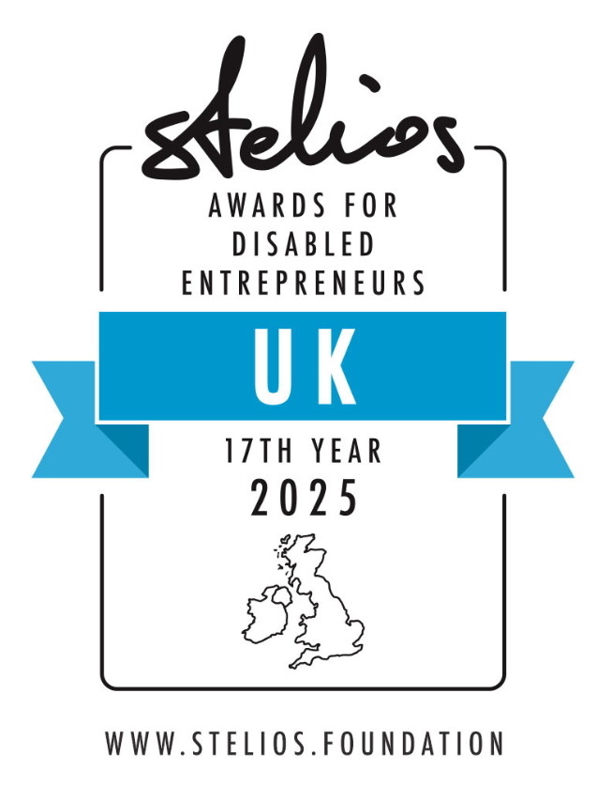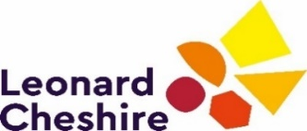
APPLICATION FORM
A total of £300,000 in cash prizes to be won by three disabled entrepreneurs in the UK! Now in their 17th year with these awards, Sir Stelios and his Foundation have granted over £1.85m (including this year’s sums) to disabled entrepreneurs recognising their exceptional achievements. The awards are designed to inspire entrepreneurs with a disability to start their own business and be their own boss and create wealth and jobs for themselves and others in their community.

- these cash prizes are offered by the Stelios Philanthropic Foundation (www.stelios.foundation) a UK registered charity created by Sir Stelios Haji-Ioannou, the creator and owner of the easy family of brands. For more information visit: www.easy.com and www.easyhistory.info.
- From 3 April 2025 until 16 May 2025, we are inviting applications - to be submitted on this application form available to download on the website www.stelios.foundation and sent by email to maya.turnbull@stelios.com.
- The winners will be announced by Sir Stelios Haji-Ioannou via Zoom on 9 June 2025.
- The overall winner will win a prize of £150,000 with a 2nd prize of £100,000 and a third prize of £50,000 to invest in their business.
- The awards are run in partnership with the UK registered charity Leonard Cheshire who specialise in supporting people with disabilities : www.leonardcheshire.org/Stelios In addition to the above prizes the Stelios foundation has agreed to donate £50,000 to Leonard Cheshire for their help in organising the awards.

CRITERIA TO APPLY:
- Entrepreneur is eligible to apply if they are registered disabled in the UK.
Entrepreneur must own at least 50% of a UK registered for-profit company that has filed accounts with UK Companies House showing a turnover (revenues) in one year of at least £100,000.
- Entrepreneur is to be a Director of the company.

DETAILS OF APPLICANT:
First name____________ Last name________________ Date of birth___________________
Email address________________________________________________________________
LinkedIn profile of applicant____________________________________________________

Mobile phone__________________ What % of the company do you own?___________
How did you hear about these awards ?_______________________________________
Do you have a disability as defined by the Equality Act 2010? Yes/No (please delete as appropriate)

Have you applied to the Stelios Awards before? Yes/No (please delete as appropriate). If yes, please list the year’s you have applied and the name of the business/es.

DETAILS OF THE COMPANY:
Legal name of company__________________________________________________
UK Companies House website link ____________________________________________
Incorporated on (date) ____________________________________________________
Phone number (fixed line) _________________
Company postal address_________________________________________________________
Company website (URL)__________________________________________________________
Visitors per month _______________ (most recent figure)
LinkedIn page of company ______________________________________________________
In one sentence please explain what your business is

In no more than 200 words please tell us about your business in more detail. Discuss your products, if any, in what markets you operate, who your customers are, who you compete with, how it fills a need in the market, why you are passionate about it and any other details you feel are relevant.

Please tell us how your disability has impacted your business. For example, you could tell us if your disability inspired your decision to start a business or influenced you to target a specific customer base. Or you might choose to tell us some of the barriers you had to overcome to get your business off the ground.

If you won an award, how would you invest the prize money?

Financials | 2023 | 2024 | 2025 (Forecast)
Turnover (Revenues) £
Net profit £ (or loss)
Number of staff
Number of customers served per year

How would you describe your business (tick as many as applicable):

Business to consumer (B2C) ____ or Business to business (B2B) __________

Are you selling a physical product ____ or a service _________

The majority of your sales revenue is online via the internet ____ or you receive payment via offline payment methods _____

Name the three biggest direct competitors you have: _________________________

Your selling price point relative to your competitors is:
lower _____ average _____ premium _____

Without affecting your ability to win these awards, please tell us if you are willing to discuss in the future joining the easy family of brands with your current business ? yes___ no_______ if yes which easy brand would you like to use ? easy_________ In order to help you understand the business model of the easy family of brands watch the 4 minute video on www.easyHistory.info

Press/media: Please tell us about any press/media coverage you may have had, negative or positive. You may provide links if any. Please note failure to disclose negative press could exclude you from the awards.

_________________________________________________________________________

Social media: Please list all your active social media accounts across all platforms (LinkedIn, Facebook, Twitter or X, Instagram etc).
________________________________________________________________________

________________________________________________________________________

By applying for these awards, I hereby agree to:
- Allow the Stelios Foundation to process your data on the application form and publish the fact that you have applied and/or won.
- Follow the LinkedIn page of the Stelios Philanthropic Foundation London HQ.
- https://www.linkedin.com/showcase/stelios-foundation-headquarters-london/about/
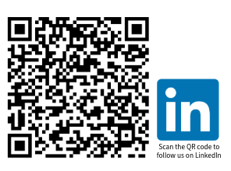
- Connect on LinkedIn with https://www.linkedin.com/in/maya-turnbull-3b62141b3/

- If you win an award, promote the awards on LinkedIn after the ceremony and include award details as a permanent logo on the footer of your business website homepage with a clickable link to the www.stelios.foundation.
- If you apply you will also be expected to promote this and subsequent year’s awards including giving media interviews and agreeing to be videoed.

I understand that all judging decisions in these awards are made by Sir Stelios and are final. I certify that the facts above are correct. I understand that the Stelios Philanthropic Foundation will process any data that I have provided on this form and in any attachments for the promotion of the Awards.

Please fill in your details below confirming your application as stated above and email the word file to maya.turnbull@stelios.com

Please refer to the terms and conditions available at www.leonardcheshire.org/Stelios .
For application enquiries, please email SteliosAward@leonardcheshire.org

Name of
applicant
Name of
Company
Date

